Lecture No.11 PARASITOLOGY DR.Raad H.H
order spirurida
contains families of :
Spiruridae ; Thelaziidae ;Acuariidae ; Filariidae ; Setariidae ;Druncunculidae
Characterized by :
- Habitats GIT, subcautanous tissue , lymph ,blood
- General form Different size worms
- Mouth shape With 2 lateral pseudolabia &6 lips .
- Esophagus form cylindrical
- Male reproductive system No cpoulatory bursa ; but have posterior coiled end with 2 unequal spicules
- Egg shape eggs of worms with L ₁
- Life cycle Indirect
- Infective stage L₃ Swallow insect intermediate host or injecting L₃ by insect intermediate host.
- Classified to 3 Super families Spiruroidea :Filaroidea ; Dracunculidea.

- Super family Spiruroidea:
Characterized by :
        - Minute nematode
        - Mouth contain 2 lateral lips each divided to 3 lobes
        - Indirect life cycle start by swallowing L3 in intermediate host .
Family Spiruridae
Genus Habronema
- Habitats equine stomach; The adults are 6-25 mm in size.
- spices Habronema muscae ; Musca spp. intermediate host; pharynx cylindrical shape
- H. microstoma , Stomoxys spp.intermediate host; pharynx inverse funnel shape pharynx
- Habronema (Draschia) megastoma; Musca spp.intermediate host; pharynx wide funnel shape pharynx
- Horses are infected by ingesting flies that contain infective larvae or by free larvae that emerge from flies as they feed around the lips.
- Life cycle indirect :
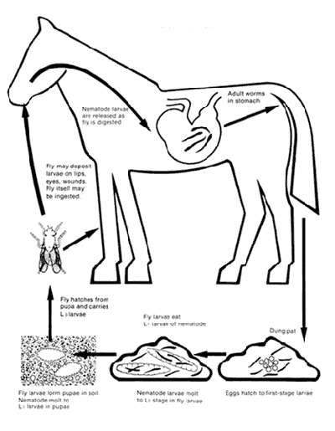
The adult worms lay eggs within the horse's stomach. The eggs are later excreted through the feces. The eggs hatch quickly after they are passed out of the horse. After the eggs are hatched in the feces, the larvae are ingested by the maggots of different types of flies that lay there in the feces (such as houseflies, and stable fly). The larvae infect the maggots for about one week, or when the maggots mature into the adult fly. The larvae migrate into the mouthparts of the fly, where they are passed on to the horse when they feed around the horse’s moist areas such as wounds, nostrils, lips, and eyes. If the larvae are deposited into the open wounds, or broken skin they can cause ulcerated irritation called “summer sores”. They may also invade the eye and the eye membrane causing a persistent conjunctivitis case. If the larvae find their way up through the nose they can migrate into the lungs and cause tiny abscesses around where they imbed themselves in the lungs tissue. When the larvae are licked and swallowed by the horse they travel to the stomach and imbed themselves into the mucus exudates. If the larvae make it into the stomach, after they are in the lungs or in the skin, they begin to mature. Once the larvae are imbedded in the stomach, they begin to mature. Once they are matured, the adults begin to migrate through the horse and begin to make eggs which will start the Life cycle again

- General Pathological effects ; due to
Larvae :
in Skin : If the larvae which are in the mouthparts of the intermediate host are deposited in the open skin well the fly feeds it can cause Cutaneous Habronemiasis "summer sores". Summer sores are ulcerated irritations. These lesions can cause soreness and itchiness and become covered in a reddish-yellow tissue.
In eyes : If the worms get deposited into the eye or the area around the eye it can cause a persistent case of Granular conjunctivitis .
In Respiratory System: If the larvae travel through the nose, into the pulmonary system and then the lungs, they can cause abscesses in the lung tissue where they imbed themselves in the lungs tissue.
Adults worm : In Digestive System When the adult worms imbed themselves into the mucus lining of the stomach in large numbers digestion can be affected ; A catarrhal gastritis may result from heavy infections with adult ; worms With even larger numbers the passing of food can be completely blocked.
- Special Pathological effects :
Draschia are found in tumor-like swellings in the stomach wall. produces the most severe lesions—tumor-like enlargements up to 10 cm in diameter. These are filled with necrotic material and a large number of worms and are covered by intact epithelium, except for a small opening through which the eggs pass. Rarely, these nodules rupture and cause fatal peritonitis.
Larvae of Habronema spp and Draschia have been found in the lungs of foals associated with Rhodococcus equi abscesses ( Rhodococcus equi pneumonia). Clinical signs usually are absent except when granulomas associated with Draschia infection lead to mechanical obstruction or rupture.
- Diagnosis : Antemortem diagnosis is difficult because the thin-shelled eggs or larvae are easily missed in fecal examinations. Worms and eggs may be found by gastric lavage.
- Treatment :starting with fasting the horse then give drench of 8-10 liters of 2%NaHCO₃ solution to dissolve tumors then give anthelmintics (Most anthelmintics have not been tested against Habronema spp or Draschia sp , although ivermectin is effective against their cutaneous larvae and against adults of H muscae . Moxidectin is effective against adult H muscae ).
- Control: There are two ways to control Habronema. The first way was stated earlier, by proper disposal of manure, since the eggs are excreted through the feces. The other way was control of fly population. The larvae are picked up by flies when they feed in the feces. The flies act as in intermediate host for the parasites, until they can find a permanent host. Proper control of the fly population (house flies, horse fly, and face fly can all carry Habronema) can decrease the possibility of your horse being infected by habronema. Those are the two most efficient ways to control the parasite habronema.
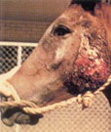

Genus Spirocerca
- Spirocerca lupi is the name of a slender reddish worm about 40 mm in length that stays in the dog's esophagus.
- Eggs of Spirocerca are excreted in the faeces of infested dogs whence they are ingested by dung beetles (coprophagous beetle).
- Infective stage L 3 inside the intermediate host beetles and will infest other dogs eating the beetles. If other animals such as lizards or birds eat the dung beetles, these animals may also harbour the worms and will infest dogs if eaten by them.
- Inside the dog's stomach the worm larvae break out of their cysts and begin their long migration via the arteries to the aorta just behind the heart. They carry on through the wall of the aorta into the wall of the esophagus where they develop into adults thus completing the process. Their life cycle may be completed in about six months, but it may take anything up to two years!
- Pathological effects (in dogs mostly ; in goat equine rarely.):
Once in the aorta, aneurisms (saclike protrusions in the artery wall) may develop that can lead to thrombosis and embolism of the back legs presenting as pain and lameness in the affected limb. These aneurisms may also rupture leading to sudden death in an affected animal.
Inside the wall of the esophagus the constant irritation of the worms on the tissues leads to thickened growths of the wall. (granulomas) The presence of these granulomas cause regurgitation or vomiting in a large number of cases. Regurgitation is a passive backflow of ingested material from the esophagus, whereas vomiting entails the active contraction of the stomach muscles to expel food already in the stomach.
Family Thelaziidae
Thelazia is a genus of nematode worms which parasitize the eyes and associated tissues e. lacrimal sac of various bird and mammal hosts, including humans. They are often called "eyeworms," and infestation with Thelazia species is referred to as "thelaziasis" (occasionally spelled "thelaziosis"). Adults are usually found in the eyelids, tear glands, tear ducts, or the so-called "third eyelid" (nictitating membrane). Occasionally, they are found in the eyeball itself, either under the conjunctiva (the membrane that covers the white part of the eye) or in the vitreous cavity of the eyeball.
All species of Thelazia for which the life cycle has been studied are transmitted by species of Diptera (flies) which do not bite, but which feed on tears.
- Thelazia lacrymalis (Gurlt, 1831)
  - Definitive hosts: Horse (Equus caballus) and Cattle (Bos taurus)
  - Intermediate hosts: Face fly (Musca autumnalis) and Musca osiris
  - Distribution: Asia, Europe, Middle East.
- Thelazia rhodesii (Desmarest, 1828)
  - Definitive hosts: mainly bovids, Cattle (Bos taurus), Buffalo (Bubalus bubalis), Zebu (Bos indicus), Bison (Bison bonasus), and sometimes Horse (Equus caballus), Domestic sheep (Ovis aries), Dromedary (Camelus dromedarius), and Goat (Capra hircus)
  - Intermediate hosts: Flies (Face fly (Musca autumnalis, Musca larvipara, and Musca sorbens)
  - Distribution: Africa, Asia, and Europe.
Family Acuariidae
- most of which are parasites of birds gizzard sometimes esophagus.
- with special character of Cordons (cords) in cephalic anterior part of the worm.
- Genus Acuaria
- Infective stage L 3 inside the intermediate host dung beetles (coprophagous beetle) ; flies grasshopper . whence they are ingested by birds it causing digestion process impairment .

- Super family Filarioidea
- These are long and relatively thin worms.
- As a rule the mouth is small and not surrounded by lips, and there is neither a buccal capsule nor a pharynx.
- The oesophagus has anterior muscular and posterior glandular part.
- Female are viviparous (microfilaria ).
- Habitats lymph ,blood , C.T. ,body caivity of definitive host.
- L3 infective stage live in the saliva of arthropod intermediate host.
- The filaroids are tissue dwelling parasites found in all groups of vertebrates except fishes.
- Microfilariae of W. bancrofti in the Caribbean, SA, Africa, and Asia are nocturnal; while those of the strain endemic to the South Pacific Islands are diurnally subperiodic – while they are present in the peripheral circulation throughout a 24 h period, their numbers increase during the day time.

Family Filariidae

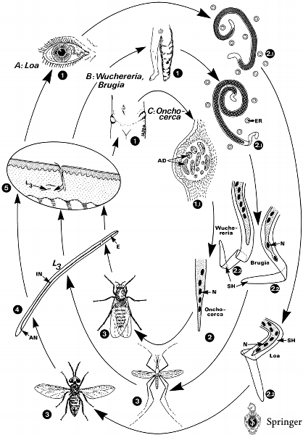

Filariidae·Fig. 1. of human filarial worms. A adult worms ( = male 3.5 cm, female 7 cm) wander subcutaneously and may pass the anterior chamber of the eye (1). B adults (male 4 cm, female 10 cm) and adults (male 3 cm, female 9 cm) live in lymph vessels and lead to a late-stage disease called (1). C adults (male 2–4 cm, female 70 cm) are knotted together in groups in the subcutaneous tissues. Because of host reactions these groups are encapsulated, leading to palpable Microfilariae may induce 1 Visible signs of diseases. 2 Microfilariae; the long-living females produce (after copulation) thousands of first-stage larvae daily, which measure about 260 × 8 μm. Their shape (2.1), structure (2, 2.2) and diurnal occurrence are species specific: they may or may not be sheathed (2.2); their terminal nuclei have a species-typical appearance (2, 2.2); they can be found in blood vessels (Loa, or in lymphatic gaps (); their occurrence in the peripheral blood can be periodical (Loa, during the day; Wuchereria, during the night; some subperiodic strains also exist), or may not be (Onchocerca, always present, but in lymph vessels). 3 Intermediate hosts: Depending on the periodic appearance of microfilariae in the host's skin, insects with different biological behavior are involved as . Daytime-feeding vectors (deerflies, spp., spp.) transmit Loa loa or Onchocerca volvulus, whereas night-feeding may be vectors of the nocturnal strains of Wuchereria and Brugia. When microfilariae are ingested by the intermediate hosts during the blood meal, they penetrate the intestine and enter the abdominal cavity and the thoracic muscles. After a the L₂ is formed, which has a stumpy shape (sausage stage). Another molt finally leads to the filariform infectious L₃. 4–5 L₃ reach a length of about 1.5 mm and migrate to the from which they escape when the vector is feeding. They enter the skin through the wound channel made by the biting insect (5, arrow). Inside the final host (man) the larvae migrate until they reach their favorite site of location, where they mature (after another two molts) within 1 year (prepatent period; ). AD, adult worms (in section); AN, anus; E, esophagus; ER, erythrocyte; IN, intestine; L₃, third larval stage; N, nuclei (their arrangement at the poles of microfilariae is species specific); SH, sheath.

Genus Parafilaria

Parafilaria bovicola

This filarial parasite of cattle causes subcutaneous lesions that resemble bruising causes hemorrhagic nodules in the skin of cattle and buffalo. ; The invertebrate hosts are face flies of the genus M. autumnalis M .lusoria and M. xanthomelas in South Africa, and M. vitripennis in Asia.

Parafilaria multipapillosa
P. multipapillosa is found in the subcutaneous tissues of horses in various parts of the world; Blood-sucking Haematobia spp are thought to be the invertebrate hosts.
causes hemorrhagic nodules (“summer bleeding”) in the subcutaneous and intermuscular tissues of horses. The nodules break open and discharge blood and then heal. They reappear each summer.

Genus Dirofilaria

Dirofilaria immitis
Heartworm is a parasitic roundworm (Dirofilaria immitis) that is spread from host to host through the bites of mosquitoes. The heartworm is a type of filaria, a small thread-like worm. The definitive host is the dog but it can also infect cats, wolves, coyotes, foxes and other animals, such as ferrets, sea lions and even, under very rare circumstances, humans. The parasite is commonly called "heartworm"; however, that is a misnomer because the adult actually resides in the pulmonary arterial system (lung arteries) for the most part, and the primary insult to the health of the animal is a manifestation of damage to the lung vessels and tissue. Occasionally, adult heartworms migrate to the right heart and even the great veins in heavy infections. Heartworm infection may result in serious disease for the host.

Other genera are :

Wuchereria bancrofti
This filarial worm is parasitic only to humans elephantiasis
Brugia malayi humans elephantiasis
Loa loa inflammatory conjunctiva ; subcutaneous tissues nodules
Mansonella Subcutaneous Filariasis

Famliy Setariidae
Genus Setaria

Setaria digitata :
a filarial parasite of urinary bladder of cattle sheep goat ; brain ,spinal cord sometimes .
Setaria equina:
a species that is a common parasite of horses and other equids in all parts of the world; they are slender whitish filaments, several inches in length, usually found free in the peritoneal cavity, but occasionally reported in the pleural cavity, lungs, scrotum, eye, and intestine.

Infective larvae L3 develop in culicine mosquitoes, including Aedes and Culex species.

Genus Dipetalonema

Dipetalonema reconditum :
is a parasite you will not hear much about since it rarely causes significant disease. Its importance lies in the fact that its immature form (slender larvae called microfilariae) can be easily confused with those of Dirofilaria immitis (heartworm). D. reconditum lives in the body cavity and subcutaneous (just below the skin) tissues of dogs and is found throughout the United States.
Dipetalonema evansi:
Host one-humped camels (Camelus dromedarius) Arabian Camel
observed in either liver,lungs or both of these organs of in 17.5% camels of Iran . nodule formation in the blood vessels.ovaries and testis leading to sterility.

Family Onchocercidae
Genus Onchocerca
- 3 species of Onchocerca currently recognized
O. cervicalis is found in the ligamentum nuchae and possibly other sites in Equidae.
In cattle, O. gutturosa locates in the ligamentum nuchae ; O .lienalis in the gastrosplenic ligament
Adults are associated with connective tissues and are very thin and 3-60 cm long. Microfilariae are found in the dermis and on rare occasions circulating in peripheral blood. The microfilariae lack a sheath and are 200-250 µm long with a short, sharply pointed tail. Culicoides spp are the intermediate hosts for O. cervicalis , and Simulium spp. for O. gutturosa and O. lienalis

fistulous withers, poll evil, dermatitis, and uveitis , fibrosis in the ligamentum nuchae, lesions often include areas of scale, crusts, ulceration, alopecia, and depigmentation; they may be pruritic. Allergic reactions in horses
- Onchocerca volvulus Human river blindness; fibrous nodules located under the skin called onchocercomas.

- Super family Dracunculoidea

Genus Dracunculus medinensis – 'The Guinea Worm'

- The disease called Drancuculuiasis .
- The worms also called "Ancient Egyptians" or "Guinea worms " infection.
- Reported in Nile valley , Africa , Iraq ,Iran ,Saudi , India & other regions in Asia .
- The worm look like Filaria; the male 70 - 120 cm. long x 0.9 - 1.7 mm. diameter ; the female 40mm. long x 0.4 mm. diameter ( rarely recover from lesion) .

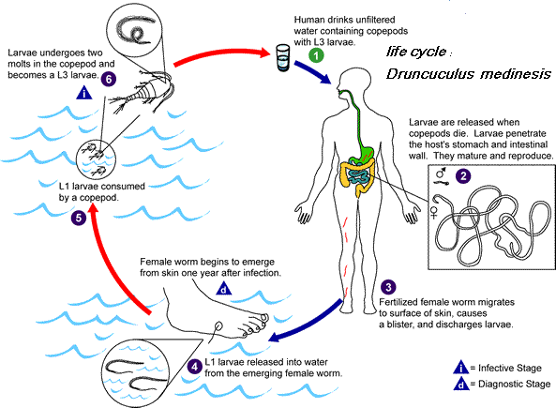

The female migrate from deep somatic & visceral connective tissue to the subcutaneous tissue near skin (within 12 months) ; papule formed turn to blister which sloughs in water when the anterior end of the worm ruptures ; then its uterus prolapsed & eject a swarm of
1st. stage larvae which enter the copepod (Cyclopes ; intermediate host) to the 3rd. infective stage larvae ; if digested by final host they migrate from intestines to the connective tissues.
- Pathogenesis & symptoms :
a. Skin blistering ; abscess ; ulceration ; necrosis due the existence of underlying worm.
b. Edema ; indurations due to release toxic substances & persistent inflammation .
c. Nausea ,vomiting , diarrhea , dyspnea &syncope.

